Grade 3 Learning Experiences: Growing a Garden Salad

Experience 3: Healthy Plants and Soils
Long Range Plan Grade 3 Model 1
Overview of learning experiences – why these activities | Students will gain an understanding of a plant, its anatomy, and the conditions necessary for a healthy plant to grow. In addition, the relationship between humans and plants. These activities will be built upon the inquiry from previous learning experiences.  Long Range Plan Grade 3 Model 1
Prior Knowledge / Prior Skill Set(s) | Background Knowledge and Concepts (Teacher)  - Familiar with all the Considerations for program planning  - Learning strategy: Knowledge Building Circle (Knowledge Building Circle  - If going to use different soils in Ontario for the plant experiment, it is suggested to do some researchonf the makeup of the soil and where you can get this type of soil.  - During consolidation, if using the high-tech option, the teacher has prior knowledge and understanding of basic block-based coding concepts, platforms, functions, and algorithms for software or robotics such as Scratch and/or BeeBot  Background Knowledge and Skills (Students)  - It is recommended that students have skills and knowledge from previous learning experiences (Experience 1: What is a Salad?, Experience 2: Where Does It Come From?)  - Students’ perspectives and prior knowledge about the topic are welcomed in the class so that everyone can benefit from the knowledge and experience of others.  - Familiarity with how scientists record their observations in notebooks and/or nature journaling  - During consolidation, if using the high-tech option, students need to have prior knowledge and understanding of basic block-based coding concepts, platforms, functions, and algorithms for software such as Scratch
Strand A - STEM Investigation and Communication Skills | A.1.1. Scientific Research: use a scientific research process and associated skills to conduct investigations  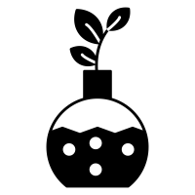 A.1.2 Scientific Experimentation: use a scientific experimentation process and associated skills to conduct investigations  A.1.3. Engineering Design (builds): use an engineering design process and associated skills to design, build, and test devices, models, structures, and/or systems  A1.4 Safety: follow established health and safety procedures during science and technology investigations, including wearing appropriate protective equipment and clothing and safely using tools, instruments, and materials.  A.1.5. Communication: communicate their findings, using science and technology vocabulary and formats that are appropriate for specific audiences and purposes  A.2 Coding and Emerging Technologies: use coding in investigations and to model concepts, and assess the impact of coding and of emerging technologies on everyday life and in STEM-related fields  A3 Applications, Connections and Contributions: demonstrate an understanding of the practical applications of science and technology, and of contributions to science and technology from people with diverse lived experiences
Overview / Big Ideas/Fundamental Concepts | Overview  These learning experiences will have students inquiring about the changes in plants along with researching the different soils in Ontario. They will be able to apply the scientific experimentation process when growing their own plant. Students will be able to consolidate their learning through coding.  Big Ideas  B2. Demonstrate an understanding of characteristics and uses of plants and of plants’ responses to the natural environment  E1. Assess the importance of soils for society and the environment, and the impact of human activity on soils  E.2 Demonstrate an understanding of the composition of soils, of different types of soils, and of processes and practices that can affect the health of soil  Fundamental Concepts  - Automation  Automation involves implementing technologies to make systems run on their own, without further human intervention. Automation can facilitate and accelerate functions that are otherwise difficult, repetitive, or dangerous for human beings to perform. Coding and emerging technologies play an increasingly important role in controlling automated systems.  - Sustainability and Stewardship  Sustainability is the concept of meeting the needs of the present without compromising the ability of future generations to meet their needs.  Stewardship involves understanding that we need to use and care for the natural environment in a responsible way and making the effort to pass it on to future generations no less than what we have access to ourselves. Values that are central to responsible stewardship are as follows: using non-renewable resources with care; reusing and recycling what we can and switching to renewable resources where possible.
Learning Goals / Success Criteria | Suggested Success Criteria that can be co-created with students based on the activities presented within these learning experiences:  Transferable Skills/Global Competencies  - I can make observations and thoughtful interpretations  - I can ask questions  - I can make connections  - I can communicate my ideas  - I can collaborate with others  - I can learn from others  Knowledge, Understanding, Application  - I show gratitude of plants and soil  - I can explain the parts of a plant  - I can explain what makes soil healthy  - I can create an animation using code  Ministry of Education Key Points  - Hands-on, Experiential Learning  - Research and Experimentation Processes  - STEM Skills and Connections  - Coding  - Food Literacy  - Climate Change  - Skilled Trades  - Coding
Learning Experience(s)  A.1.1, A.1.5, A3  A1.1, A1.5  A1.2, A1.4, A1.5, A3  A1.1, A2., A3, A.1.5 | Minds On (30 - 40 mins)  Purpose of the Minds On is to deepen their observational skills while understanding more about the behavior of plants and soils. They will be introduced to the concept of ecological reciprocity. This will allow the teacher to learn about students’ prior knowledge.  “Plant Inquiry”  - If possible, take the learning outdoors where students have access to plants (e.g., flowers, vegetables, weeds). Have students spread out so they have access to natural phenomena?  Alternatively, bring into the classroom flowers (or another type of plant) in a pot (1 for each group of students). Or show them images of healthy-looking flowers growing in healthy soils projected in the classroom.  - Use this time to begin with a land acknowledgment. Remind students that we are thankful and respectful of what we see and touch. We will not damage or take any of the natural environment. Create a class expectation that we can take a small piece of nature if there is an abundance of it (e.g., grass). If there is less than a handful, then we do not take. We treat the plants the same way the plants treat us. This is part of the traditional ecological knowledge we are sharing with our students. If time and resources permit, invite a community elder to speak to the students about land-based learning. A community elder could also share information about how they use plants.  - Explain to students that we are determining what makes a plant and soil healthy? As scientists, we observe and wonder. Students may want to have their journals handy. If magnifying glasses are accessible, have students use those to get a closer look at the parts of a plant and soil. Allow plenty of time for students to observe since this will help students develop a relationship with the natural environment.  - Ask students to record their observations. Explain to students that the reason for this activity is to better understand the behaviour of plants and soils. Suggest that students may wish to use words, pictures, and numbers. They may wish to draw a plant with all the parts they see. They may want to label the parts. Also, have them touch and observe the soil. What do they see? They may want to look closely and draw all the contents of the soil. What do they feel? What are they wondering? Have them record their observations along with any possible questions they may have. Emphasize that this is not art and that their journal entries do not need to be “pretty.” The goal is pure observation. The teacher may wish to demonstrate using a handheld dry-erase board or notebook to help students understand what a sketch or nature journal entry may look like.  Using words, pictures and numbers lead to deeper observation. Use prompts such as: I notice.. I wonder.. It reminds me of…  The teacher can walk around and conference with individual students about their discoveries. Scribe for students as necessary.  Curiosity and Wonder in Science and Technology  - Back in the classroom, have students share their observations and wonderings with a partner first. This is a great opportunity for the teacher to walk around and observe student discussions and check their journals.  - After both partners have had a chance to share, ask if there are any students that would like to share with the rest of the class.  Action  Part 1 (20-30 mins)  Use a non-fiction book, text, or video to introduce to students the basic concepts of a plant (e.g., parts of plant, plant cycle, what they need to survive)  Suggested videos:  Eng: From Seed to Flower | PBS LearningMedia  There are more book suggestions in the Additional Supporting Resources  Pause to discuss with students. During the pause, the teacher may want to create a classroom anchor chart such as parts of a plant, plant cycle, and/or what plants need to survive. (These anchor charts will help with science literacy).  See Appendix A: Parts of a Plant for sample anchor charts:  Review what plants need to survive (e.g., sun, water, oxygen, soil). Ask students, can water be healthy or unhealthy? Can the air we breathe be healthy or unhealthy? Can we say the same about soils? Are soils healthy and/or unhealthy?  Think pair share: what kinds of soils did you notice outdoors? Was the soil healthy? How do you know? How important is soil for plants? Is soil important for humans too?  Use this Let’s Talk Science presentation: Healthy Soil to go over all about soils as a class. You could take out the photos of healthy and unhealthy soils from the presentation, have them printed then distributed among groups of students to talk and discuss what they notice and wonder about the soils. Discuss how humans impact soils. How does the climate change soil? What are the living and nonliving components of soil?  At any point during these discussions use the Knowledge Building Circle where students build upon one another’s ideas and offer new ideas. This is a great way for the teacher to step back and listen to students’ inquiry, ideas, knowledge, and understanding, etc. Take the time to write anecdotal notes or use a tally chart for tracking purposes.  See Appendix B: Knowledge Building Circle Tracking Sheet for a suggested sample classroom recording chart  Part 2 Plant Experiment (60 mins + additional days)  - Follow the Scientific Experimentation Process for the plant experiment. Have students follow along in their journals for the process or the teacher can model the steps on chart paper (especially if this is the first time this year students are introduced to the process)  - Follow established health and safety procedures, including wearing appropriate protective equipment and clothing and safely using tools, instruments, and materials  Define a problem and its context:  Explain to students that they will be growing a plant and observing its growth (the stages) and learning about it like scientists. Try using different soils when planting to see if the results will be different. First, determine the types of soils in Ontario. Use this interactive map from Soils of Canada - Agriculture and Agri-Food Canada to gather the different types of soils. (e.g., Brunisolicm Chemozemic, Crysoloic, Gleysolic, Luvisolic, Organic). What are the ingredients that make up this soil? Research where you can get this soil for the experiment. You may also want to have a soil scientist speak to your class and give you more information about the types of soil in your region.  Alternatively, if you are unable to gather the soil for the experiment, do research about the different soil you can purchase at your local hardware store and which soil is best for the type of plant. If possible, have an expert from a local nursery talk to students about growing particular plants in certain soils to help determine which soils and/or plants to purchase.  Design the experiment  Choose the seeds that you want to use (e.g., ingredients of salad garden - which may take a while to germinate - or stick with beans which will be faster for the purpose of the experiment). Give students a chance to choose.  Choose the soils that you will be using.  Discuss a plan as to how will the plants receive all their needs. Where will they be placed? How will students record a plan of observation?  Conduct the experiment:  Have the soils ready in clear plastic containers. Students can take the time to express gratitude for beginning to start life with the seed (e.g., land acknowledgment, giving thanks). Sow the seeds. Water the seeds. Place the containers in a well-lit area. Follow any required safety procedure.  If using small containers and the plant grows large, transplant the plant into a larger pot. Explain to students the importance of having a larger pot so that the roots of the plant have more space to grow.  Record data  Students can begin recording what they see on Day 1. Have them draw in their journals what they see and label the parts (e.g., soil). They can record every day or every second day. Make sure they check for healthy soil (e.g., water if the soil is dry). How do you know when the soil is dry? How do you know if the soil has too much water?  Analyse and summarize the data  You can wait until the plant has flowered or the fruit has started to begin analysing and summarizing the data. How long did it take for the seed to germinate? to grow a stem, flower? Why didn’t a fruit produce? This is also a great opportunity to introduce the purpose of pollinators. Depending on student interest and inquiries, this may lead to further lessons about the impact of climate change and pollinators.  Communicate results  Students may communicate results in a slide deck, conference with a teacher about journal entries, etc. (medium of their choice). Or they can also communicate their results with the consolidation activity of coding.  Consolidation (30-40 mins depending on the type of coding activity chosen)  Students will demonstrate their understanding of the life cycle of a plant along with healthy soils through a coding activity.  - Ask students to code an animation of a plant cycle. They may use an application familiar to them such as Scratch Jr or Scratch. Alternatively, students can show their understanding through coding robotics (e.g., BeeBot, Ozobot) or an unplugged activity.  - Co-create success criteria with your students of what should be included in the animation. See Appendix C: Plant Animation Success Criteria.  - Students may want to plan out their animation in draft form before coding. Use this template to map out ideas.  Block coding: Scratch  Here is an example of a plant cycle animation using Scratch. Students may want to remix if they have a Scratch account. If they have created a pattern in their algorithm, they may want to see how they can improve their code using a repeat block.  Robotics (e.g., BeeBot)  Create a mat for the robot with pictures of the different stages of the plant life cycle. Have students code the robot to land on the proper stages in order of the life cycle. Here is a sample photo of a simple pumpkin life cycle BeeBot mat. Students can record the algorithm they used and write it on paper for assessment of learning.  Jamboard  Use the forced copy Jamboard to get students to code through the stages of a plant cycle. Plant Cycle Jamboard.  Unplugged  If you print images of the different stages of the life cycle and place them around the classroom, students can move like a robot (counting their strides toward the appropriate images) and turn left or right. They can record the path they took on paper. The teacher can use the paper for assessment of learning. Observations of students conducting the activity will be assessment AS learning.
Science and Technology Expectations | B. Growth and Changes in Plants  B2. Exploring and Understanding Concepts  B2.1 describe the basic needs of plants, including the need for air, water, light, heat, nutrients, and space, and identify environmental conditions that may threaten plant survival  B2.2 identify different parts of plants, including the root, stem, flower, stamen, pistil, leaf, seed, cone, and fruit, and describe how each part contributes to plants’ survival within their environment  B2.3 describe changes that different plants undergo in their life cycles  B2.4 describe ways in which a variety of plants adapt and/or react to their environment and to changes in their environment  B2.5 demonstrate an understanding that most plants get energy directly from the Sun through the process of photosynthesis, which involves the absorption of carbon dioxide and the release of oxygen  B2.6 describe ways in which people, including Indigenous peoples, from various cultures around the world use plants for food, shelter, medicine, and clothing  B2.7 describe various plants used for food, including those grown by First Nations, Métis, and Inuit, and identify local settings where these plants are grown or found  B2.8 describe ways in which plants and animals, including humans, depend on each other  E. Earth and Space Systems  Soils in the Environment  E1. Relating Science and Technology to Our Changing World  Specific Expectations  By the end of Grade 3, students will:  Soils in the Environment  E1.1 assess the importance of soils for society and the environment  E1.2 assess the impact of human activity on soils, and describe ways in which humans can improve the quality of soils and/or lessen or prevent harmful effects on soils  E2. Exploring and Understanding Concepts  E2.1 identify the living and non-living components of soil, and describe the characteristics of healthy soil  E2.2 identify different substances that are commonly added to, or absorbed by, the soil, and describe their effects on soil health  E2.3 examine different types of soils found in Ontario, and describe how different soils are suited to growing different types of food, including crops  E2.4 explain the process of erosion, including its causes and its impact on soils
Science and Technology Vocabulary | - nutrients  - oxygen  - erosion  - seed  - root  - stem  - flower  - leaf
Equipment and Materials | - plants to bring in the classroom (optional if not going outdoors)  - science or nature journal (students)  - small dry erase board or notebook (teacher) (if going outside)  - pencil/eraser  - clipboards for students (optional)  - magnifying glasses for students (optional)  - chart paper / markers (teacher)  Plant experiment  - seeds (salad ingredients, or stick to one consistent plant like beans)  - soils (Ontario soils or packaged soils from local hardware store)  - clear plastic containers are recommended to see the germination process, otherwise regular seedling pots (or recycled materials such as egg cartons, cup cartons).  - larger pots for plant transplantation  - water  - access to light (e.g., windowsill)  Coding (choose 1 of the following suggestions)  - Computer/device with access to Scratch or Scratch Junior, Google Jamboard (optional)  - Robots (e.g., BeeBot) (optional)  - Images that represent stages of a plant life cycle for unplugged activity (optional)
Timeline and Preparation | Times can be shortened or extended based on student engagement, interest, and inquiry.  - Minds On (30-40 mins)  [Optional Preparation of setting up plants (5-10 mins)]  - Action  - Part 1 (20-30 mins) Preparation (5 mins)  - Part 2 (60 mins) Preparation (20 mins) + additional days of observations/recording  - Consolidation (30-40 mins depending on the type of coding activity) Preparation (10 mins)
Safety Considerations | There are no high-risk activities or experiments within these learning experiences. Always refer to the following documents when considering safety for the teacher and the students:  - Safety in Elementary Science and Technology (STAO)  - Safe Activity Foundations in Education Document (SAFEdoc) Science and Technology, Grades 1-8 (OCTE)  - Ontario Curriculum Program Planning – Health and Safety
Opportunities For Assessment | Assessment FOR Learning  - Observations of students’ conversations during plant inquiry activity, the information they share with a peer in the classroom, and/or when they share with the whole class  - Students initial sketches of plants and soils in their journals  Assessment AS Learning  - Observations of student sharing ideas, asking questions, communicating with peers  - Knowledge Building Circle (Track Sheet)  - Observations of students working on experiment  - Student recording of observations within their journals  - Observation of unplugged coding activity  Assessment OF Learning  - Journal entry  - Scratch Coding  - Unplugged coding algorithm written on paper  - Observation of BeeBot coding activity  - Storyboard animation  - Appendix C: Plant Animation Success Criteria
Instructional Strategies and Adaptability | This learning experience makes use of a variety of instructional strategies based on Considerations for program planning. Please review these considerations for program planning while you implement, adapt or change strategies within daily classroom practice, based on the students’ profiles.  Strategies that can support learning in your classroom:  - Leveraging digital (e.g., digital journal, record voice memos)  - Giving student voice and choice (options for communicating their learning, tools for learning, and options to work in different learning environments/spaces around the school)  - Pulling from students’ lived experience (e.g., what gardening, farming looks like in other countries or in their homes)  - Building vocabulary collaboratively (e.g. use of images and creating an interactive word wall)  - Offering visuals to support language learning  - Using assistive technology to access texts (E.g., Google Read&Write)  - Offering multiple ways of showing understanding or communicating their ideas (e.g., drawing pictures, taking pictures, recording videos, etc.)  - Using the triangulation of data (e.g., observations, conversations, and products).  - Prompt students as required. Simplify resources and support as required. Enhance learning opportunities with extension activities where required.  - Providing resources (e.g., students benefit from having vocabulary and definitions on a handout sheet close to them or close proximity to a bulletin board/anchor charts)  - Scribing for students when necessary
Additional Supporting Resources | Book:  - From Seed to Plant  by Gail Gibbons  978-0823410255
Cross-Curricular Opportunities | Math  Can represent a plant life cycle through code. (Coding)  Managing and analysing data collected about their plant growth. (Data Literacy)  Language Arts  Journal entries; a conversation about texts; think-pair-share; sharing ideas in the classroom; communicating results of experiment  Health and Physical Education  Discussion about how food is grown, harvested, etc. The type of soil affecting the nutritional value of the plants. (Healthy Eating)  Social Studies  The geographical location of different soils across Ontario.  Introduction to soil scientists and other similar careers. (People and Environments)  .
Future Opportunities / Next Steps | Further Opportunities  - Transplant the plants into your school garden or local community garden. This will lead to further opportunities to watch the plants grow and harvest.  If school gardens are unavailable, use this opportunity to design, plan and create one. Alternatively, learn how your class can take action and find ways to create a local community garden. If the previous options are not possible, donate the plants or have students take the plants home.  - Learn about the Haudenosaunee Three Sister gardening and its impacts on soil and plants. If possible, grow the three types of plants in your school garden. Invite an elder to come and talk about this type of gardening. Are there other “sisters”?  - Code a pH Meter (e.g., micro:bit) to determine the pH of different soils.  - Experiment with seeds of the same plant but with different expiry dates to observe if the germination rates differ with the age of the seed.  - Code an animation demonstrating the role of photosynthesis in plants.

Appendix A: Parts of a Plant

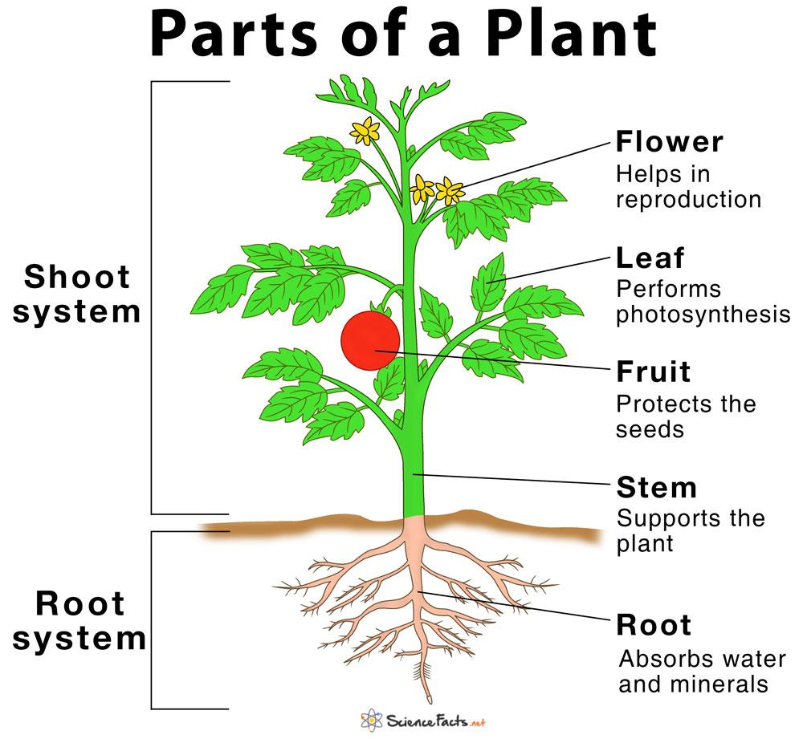

Source: Main Parts of a Plant, Their Functions, Structure, Diagram

Appendix B: Knowledge Building Circle Tracking Sheet

Knowledge Building Circle Tracking Sheet

Big Question/Topic: ___________________________________________________________ Date: _________________________

Student | Response/Comment | Connection | Idea | Question | Build-On

Appendix C: Plant Animation Success Criteria

Plant Animation Success Criteria

- I can use code to animate the basic needs of a plant such as air, water, heat, light, nutrients, and space.
- I can use code to animate parts of the plant such as the root, stem, flower, stamen, seed.
- I can use code to animate the 5 stages of the life cycle
- I can show a healthy type of soil for the plant to grow
 | Met | Not Met | Comments
I can use code to animate the basic needs of a plant such as air, water, heat, light, nutrients and space.
I can use code to animate parts of the plant such as the root, stem, flower, stamen, seed.
I can use code to animate 5 stages of the life cycle
I can show a healthy type of soil for the plant to grow

