Grade 7 Explore and Investigate the UN Sustainable Development Goals

Experience 1: What are the SDGs?
This a two-part lesson will enable students to explore and investigate the UN 17 Sustainable Development Goals ​​
Part I of this lesson will have students work in small groups and complete a graphic organizer. Students discuss ways in which the SDGs affect their local communities and will rank in order of importance. Students will research and analyze a local problem and will create an infographic to communicate findings to the local community.
Part II, students will utilize the engineering design process through an ice melt challenge. As students acquire new information from observing their prototypes, they will be challenged with improving and learning from previous designs to create a final solution.
The Engineering Design process involves students initiation and planning solutions, performing tests, recording data, analyzing results, and communicating final solutions.
This activity will deepen understanding of concepts associated with heat transfer in the environment. Students will be encouraged to integrate their knowledge of Strands C and E.
Grade 7 Long Range Plan: Model 1
Grade 7 Long Range Plan: Model 2 - December/February

Overview of learning experiences – why these activities | Students will explore the UN’s Sustainable Development Goals. Students will research each of the 17 goals and complete a graphic organizer. They will explore how the SDGs can help find solutions to problems within their local communities and what impact this can have on achieving the global goals.  Students will explore the SDGs  Grade 7 Long Range Plan Model 2 - December/February
Prior Knowledge / Prior Skill Set(s) | Background Knowledge and Concepts (Teacher) - Additional teacher concept support  - Teacher should be familiar with the UN Sustainable Development Goals initiative  - Plan Canada - SDGs  - Thermodynamics  - Insulators and Conductor  - Teachers should have some initial knowledge of the Design Engineering process and Expectations from Strand C and E  Background Knowledge and Skills (Students)  - Students may have some experience with design and building projects and process  - Background knowledge on concepts from Strands C and E
Strand A - STEM Investigation and Communication Skills | 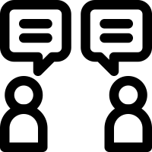 A1.5 communicate their findings, using science and technology vocabulary and formats that are appropriate for specific audiences and purposes  A3.2 investigate how science and technology can be used with other subject areas to address real-world problems  A3.3 analyse contributions to science and technology from various communities
Overview / Big Ideas/Fundamental Concepts | This exploration will focus on the foundational aspects of the design engineering process. Students will work through a design and build an ice melting model and will work through the steps of the EDP while linking understanding of concepts from Strand E.
Learning Goals / Success Criteria | Students will create and evaluate an ice melt model and are challenged with melting the ice the fastest. The main goal of this activity is to familiarize students with the engineering design process. Students can apply concepts in thermodynamics and energy (convection, conduction, and radiation) to solve this challenge.  These goals will be co-created with students and can also include classroom decided design challenges/limitations such as: limiting weight of model, amount of material, type of material etc. Create success criteria with students and share “I Can Statements” based on the curricular expectations.  Learning Objectives  - Explore how materials can affect the rate of temperature change  - Use tables, chart, notebook to organize observations  - Explain background concepts including materials and heat transfers and how this relates to everyday life.  - Recognize and list common insulators and conductors  - Explain why engineering a design is an iterative process.  Ministry of Education Key Points  STEM Skills and Connections: Perspectives and approaches that provide opportunities for students to investigate and apply concepts and skills from all areas of learning.  Research and Experimentation Processes: Provides students with the scientific literacy skills needed to approach scientific questions that are becoming a part of everyday life.  Engineering Design Process: Provides students with support to plan and build solutions to problems or address needs that connect to the curriculum and the world around them.  Hands-on, Experiential Learning: Includes hands-on, experiential learning opportunities to support classroom activities that encourage curiosity
Learning Experience(s)  A1.1, A1.5, A.3 | Part I: UN Sustainable Development Goals  Minds On  Guide student discussion using some of the following questions:  - List of things you care about (Example: swimming, environment)  - How have humans impacted these things?  Action (40 - 50 minutes)  UN Sustainable Development Goals  United Nations Sustainable Development Goals  Refer to the slide deck here  - Working with a partner or small group, have a look at the image of the 17 UN Sustainable Development Goals.  - Focus on what each goal means to you without further research.  - Brainstorm or rank in order of personal importance and explain why two sustainable development goals are important in their own life.  - You will then compare your rankings and meanings with other groups, in order to discuss similarities and differences. You may be asked to share with the whole class.  - Please use the graphic organizer provided (see Appendix A: Graphic Organizer - Exploring SDGs).  Consolidation (5 minutes)  Students will reflect on the SDGs and will write a 1 minute essay exit ticket. Students are challenged with writing 1 minute straight. Stress that there are no wrong or right answers.  Set a timer on the board and have students complete an exit ticket. This can be paired with fun music and a prompt question.  For example: We started this lesson by asking you to list the things you care about, what are some small things you can do that align with the global goals that will positively affect what you or your peers care about
Science and Technology Expectations | Overall & Specific Expectations from the Science and Technology curriculum  Stand E: Earth and Space Systems- Heat in the Environment  E1. Relating Science and Technology to Our Changing World  E1.1 assess the social and environmental benefits of technologies that reduce heat loss in enclosed spaces or heat transfer to surrounding spaces  E2.7 describe the role of radiation in heating and cooling Earth, and explain how greenhouse gases affect the transmission of radiated heat through the atmosphere
Science and Technology Vocabulary | Design engineering  Prototyping  Rapid prototyping  Iterative  Heat transfers  Thermal equilibrium  Insulators/insulation  Conductors/conduction  Radiations  Heat  Temperature  Thermal energy  Kinetic energy  Absorb  Radiant energy
Equipment and Materials | Student Materials  - Internet access (computer, iPad etc.)  - Blank paper and pencil  - Chart paper or whiteboard  - Scissors  - Ruler
Timeline and Preparation | Mind’s On 5 mins  Action  Graphic Organizer 20 mins  Infographic 30 mins  Consolidation  1 minute essay prompt 2 mins
Safety Considerations | Be mindful of internet use and practice standard online safety and monitor student devices.  Refer to these safety resources:  - Safety in Elementary Science and Technology (STAO)  - Safe Activity Foundations in Education Document (SAFEdoc) Science and Technology, Grades 1-8 (OCTE)  - Ontario Curriculum Program Planning – Health and Safety
Opportunities For Assessment | Achievement Chart - Knowledge and Understanding, Thinking and Investigation, Application, Communication  Sample Achievement Chart  Prepare an achievement chart (as seen above) that relates to the specific learning goals and aim to appeal to the interests, preferences and learning styles of the student within your classroom.  Allow students to determine what a successful prototype looks like to ensure that students at the outset of learning have a shared understanding of the learning goal and criteria as learning progresses.  Assessment “for Learning” and “as Learning”  Provide ongoing descriptive feedback in various forms that are clear, specific, meaningful and timely to support improved learning and achievement as outlined by the Ontario curriculum resources (Assessment and Evaluation Fundamental Principles)  Integrate assessment as learning in the form of success criteria and ensure students are setting individual goals and monitoring their own progress and thinking. This can be done by having students document prototype successes and modifications  Students can also peer assess prototypes after the presentation of final products.  Provide a variety of means of assessment: conversations, observations, and/or products  Assessment pieces, exemplars  Graphic organizers  Rubrics or checklists  Include opportunities to showcase engineering design process  Example Engineering Design Process Rubric (see Appendix B: Engineering Design Rubric)
Instructional Strategies and Adaptability | Inclusive curriculum and assessment practice recommendations:  - show people of different sex, races, abilities, and ages in non-stereotypical settings, occupations, and activities  Educators should aim to address the achievement gap between groups of students. This may include various factors such as gender, ethnocultural background, socioeconomic status, special educational needs, language proficiency, etc.  As such, educators should use classroom materials and/or contexts that reflect the diversity of their classrooms and school community.  Educators should foster a classroom environment that is inclusive and safe for all students. Refer to the Equity and Inclusive Education Strategy/Action plan  Teachers should adapt the lessons based on the needs of the students in their class (Please refer to the Learning for All document and the Supporting ELL Learners Document)  Please use the following links below for further reference:  https://www.dcp.edu.gov.on.ca/en/program-planning/considerations-for-program-planning/human-rights-equity-and-inclusive-education
Additional Supporting Resources | Heat Transfer -Crash Course YouTube video
Cross-Curricular Opportunities | Students are able to gather quantitative data (temperature change) and graph the data.  Students can also create an infomercial video/presentation to “sell” or market their new design.
Future Opportunities / Next Steps | Post Activity  Communication of Results - students can create a presentation demonstrating the EDP steps that they used in their challenge and share it with the class.  Reflection  What went well with your design?  What did not go well?  What changes could be made to improve this process?

Appendix A: Graphic Organizer - Exploring SDGs
Exploring The SDGs

UN Sustainable Goals | Meaning | Ranking | Why?
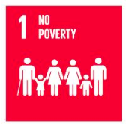
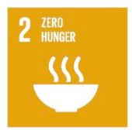
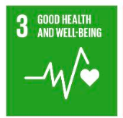
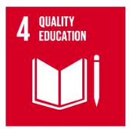
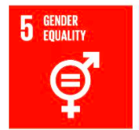
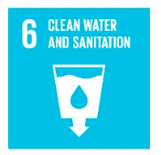
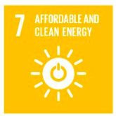
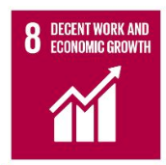
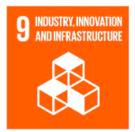
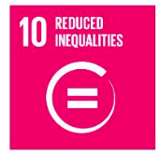
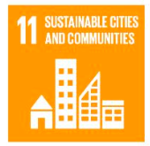
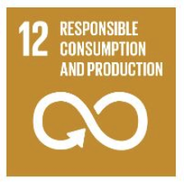
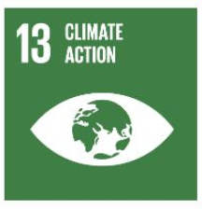
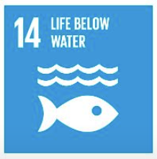
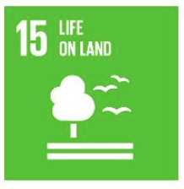
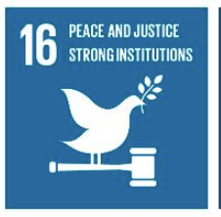
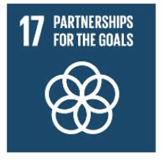

Appendix B: Engineering Design Rubric

 | Level 1 | Level 2 | Level 3 | Level 4
Brainstorming  Identify a variety of possible solutions to a problem | Little to no evidence of research or brainstorming observed or documented. | Some evidence of brainstorming observed and documented | Good evidence of group thinking, research, and brainstorming of ideas and concepts. | Excellent evidence of group thinking, implementing research in the brainstorming of the design.
Plan the Prototype  Select a design meets the goal and identified design constraints | Little or no evidence of a design plan and/or material selection. | Some evidence of a plan with little reasoning for material selection. | Good evidence of plan and rationale for material selection. | Excellent evidence of structural planning and demonstrates strong rationale for material selection.
Build a Prototype  Create a working prototype to test and evaluate the functionality | Little or no evidence of group effort to use time wisely, use materials sparingly to plan a prototype. | Some evidence of good use of time, materials, and plan. | Good use of time, troubleshooting, overcoming building challenges and attempts to maximize use of materials. | Excellent use of time. Demonstrate efficiency with material use and used and/or modified plan accordingly to overcome design and building challenges.
Collaboration | Little to no collaboration and teamwork evidence. Little evidence of leadership or compromise. | Some evidence of effective collaboration and teamwork. Occasional compromises are made with some ineffective and effective criticism of other’s ideas. | Good and effective collaboration and teamwork are evident throughout. Constriction is equal and fair throughout most of the project. | Evidence of excellent collaboration and teamwork. Positive attitude and strong connection between group members and contribution is equal and fair.
Communication  Present a final analysis of the design to an audience | Communication of design is not appropriate for the audience and lacks crucial information. | Some key design strengths and improvements are identified | Design strengths and limitations are clearly communicated in a way that is appropriate for the audience. | Clearly and efficiently communicates strengths and limitation of design. Demonstrates strong understanding of design flaws (if any) and suggests future recommendations to improve design

