Grade 8 Let’s make our planet better, one drop at a time!
Experience 3: Case Studies
Overview
In this STEM-based, engaging activity, students get an opportunity to embark on a journey in which they will discover how various human developments impact our watersheds and our water and evaluate the quality of drinkable water and the factors that may affect it.
They will start by exploring the UN’s and Canada’s sustainability goals and their importance, putting emphasis on the goals relating to water quality and the importance of protecting water. This is important so they can see that the world appreciates that we do need to take immediate actions to remedy the situations and make our planet a better place to live. (1 period of 75 minutes)
They will then get to choose specific aspects of various drinking water sources and conduct tests and experiments to evaluate the quality of water from their community’s bodies of water. They will compare their findings to Canadian standards. (2 periods of 75 minutes)
Students will then explore how developments and anthropogenic factors can impact Ontario’s water quality. This will be accomplished through a case study to understand the impact of Enbridge’s line 5 on the Great Lakes which has and will continue to have detrimental effects on all that rely on that fresh source of water. They will then use their findings to build a model of the affected watershed and of the pipeline. (3 periods of 75 minutes)
In the final step, familiarize themselves with the wastewater treatment process. They will then go on to code, using Scratch, an animation that will enable them to simulate a step or more in the process of wastewater treatment, to mimic a situation of an oil spill in Lake Erie or Lake Ontario or to raise awareness about an issue related to the water quality of their choice based on what they would like to emphasize (2 periods of 75 minutes).
Long Range Plan Grade 8 Model 1; December/January. Big Idea: Water

Overview of learning experiences – why these activities | In this Experience, students will explore how developments and anthropogenic factors can impact Ontario’s water quality. This will be accomplished through a case study to understand the impact of Enbridge’s line 5 on the Great Lakes which has and will continue to have detrimental effects on all that rely on that fresh source of water. They will then use their findings to build a model of the affected watershed and of the pipeline. (3 periods of 75 minutes)  Big Idea: Water - Environmental and Social Impacts:  LRP Grade 8 Model 1 - December/January French  LRP Grade 8 Model 2 - December/January French
Prior Knowledge / Prior Skill Set(s) | Background Knowledge and Concepts (Teacher) - Additional teacher concept support  - Students should have a basic understanding of the main properties of fluids (for example, that oil and water don’t mix).  - Students should know that they will be exploring important issues studied in the module on hydrographic systems.  - Canada shares the Great Lakes with parts of the United States (for example a few years ago the Canadian and American authorities learned to make changes to the Boundary Waters Treaty of 1909, which would have diverted some of the water from the Great Lakes to other parts of the United States or pick it up).  - Students need to understand what watersheds are and have an appreciation for their importance.  - Students need to remember that access to resources and clean water is an important issue all over the world and is being highlighted by the United Nations.  - Students and teachers should have a basic understanding of the United Nations Declaration on the Rights of Indigenous Peoples (UNDRIP) (see the Additional Resources section for more information).  - Teachers should be familiar with the 1977 Pipeline Treaty (see the Additional Resources section for more information).  - Students and teachers should be familiar with the Truth and Reconciliation Commission’s Calls to Action (see the Additional Resources section for more information).  - Teachers should understand that the treaty partners in Ontario who are affected by the Line 5 and Highway 413 extensions (see Experience 3) are the Mississaugas of New Credit, Six Nations of the Grand River, Chippewas of Georgina Island First Nation, and the Mississaugas of Scugog Island First Nation.  Background Knowledge and Skills (Students) – Addressing misconceptions and preconceptions  - The Engineering Design Process will be applied in this unit. The students should know how to conceive a design fitting established criteria and put to test their critical thinking skills. By going through this process, students will experience firsthand what it takes to create a successful product and what innovation is.  - Students will also use their communication and presentation skills to communicate and present their ideas and findings.  - Students will use their social skills as they will work in groups to explore various topics.  - Students will use and reinforce their research skills as they find answers to their questions and solutions to the presented problems.  - Students should also have basic programming skills.
Strand A - STEM Investigation and Communication Skills | A1. STEM Investigation and Communication Skills  use a scientific research process, a scientific experimentation process, and an engineering design process to conduct investigations, following appropriate health and safety procedures  A1.1 Scientific Research: Understanding the issues. Students will use their scientific research skills to explore and analyze the issues surrounding Line 5 or Highway 413 from various angles.  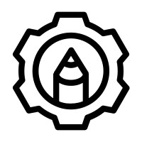A1.3 Engineering Design: Build a model that represents the projected highway and includes all local watersheds  A1.5 Communication: Communicate their observations and conclusions of their model explain how this will affect ecosystems, watersheds and species  A3 Applications, Connections and Contributions Were local Indigenous communities consulted on the development process? Were The United Declaration of the Rights of Indigenous people Article 23, Article 26, Article 29, Article 32, Article 37upheld? (Part 3)
Overview / Big Ideas/Fundamental Concepts | In this 4 part lesson, the students will go through various learning experiences to deepen their knowledge about the impact of humans and developments on a vital source; water.  In the first part, they will be introduced to the UN’s sustainable development goals and will develop their social and presentation skills as they learn about those.  In the second part, they will use their research skills and scientific process to test the water quality of various sources in their neighborhood. They will learn that there are set water quality standards in our province and these must be respected for water to be drinkable (if testing drinking water) or healthy enough for aquatic organisms.  In the third part, the students will do a case study. There are two options; option 1 will explore the case of Enbridge’s pipeline 5 and the issues surrounding it. In option 2, they will explore the impact of the construction of Highway 413. In both options, the students will see how these developments affect the surrounding watersheds. They will get to make links to history and politics as they see how the indigenous people and treaty laws and UNDRIP are being violated. Students will finally use the engineering design process (see this presentation on the Engineering Design Process)to represent these developments using models and propose alternatives that align with the UN’s Sustainable Development Goals.  In the last part, students will code a program to either simulate a situation where a chosen development is impacting a water source or watershed of their choice OR use their programming skills to raise awareness about an issue related to water quality.
Learning Goals / Success Criteria | There are a few assessment opportunities in these lesson parts:  Assessment OF learning;  In this case study lesson, the students will have to create an infographic to present their findings (see Appendix E: Infographic Rubric). The teacher should present the rubric and elaborate on it with the students before they start the task so they can make sure all the success criteria are met.  Likewise, as the teacher presents to the students the Engineering Design Process and all its steps - they should discuss together the success criteria for this and for Model-Building. The teacher can then present the provided rubric to them before they begin the Engineering Design Process.  Ministry of Education Key Points  - STEM Skills and Connections: Perspectives and approaches that provide opportunities for students to investigate and apply concepts and skills from all areas of learning.  - Research and Experimentation Processes: Provides students with the scientific literacy skills needed to approach scientific questions that are becoming a part of everyday life.  - Engineering Design Process: Provides students with support to plan and build solutions to problems or address needs that connect to the curriculum and the world around them.  - Hands-on, Experiential Learning: Includes hands-on, experiential learning opportunities to support classroom activities that encourage curiosity  - Coding: Allows students to explore a wide variety of science and technology concepts and contexts through coding, while also learning valuable skills related to the automation and control of systems.
Learning Experience(s)  A1.1  A1.1, A1.5  A1.1  A1.1  A3  A1.3  A1.1  A1.1, A1.5  A1.1  A1.3 | Experience 3A - CASE STUDY  Students can use this Student Activity Guide for this Experience (see Appendix A: Case Study 3A Line 5 Pipeline).  Understanding the issue:  Individually, the students to start by reading these two short articles about Line 5 from Environmental Defense to understand the issue at hand.  o Part 1: (4 minute read): Busting Enbridge’s Line 5 Myths Part 1 from environmentaldefence.ca.  o Part 2 : (5 minute read): Busting Enbridge’s Line 5 Myths Part 2  Students will be building a model of the Lake Superior watershed, showing Bad River and Line 5 passing through it. Alternatively, students can build a model of Line 5 passing through Lake Ontario and Lake Erie.  Optional homework: students can brainstorm how to build the watershed and make a list of the materials needed. Since this is a class project, the students can divide the list of materials among them and see what the school can provide as well.  Alternatively, the class can be split into two groups, group 1 will read part 1 and group 2 will read and analyze part 2, then a spokesperson will summarize their article in front of the class to the other team.  Group Activity – Diving In.  The teacher splits the class into 5 groups. Each group will be assigned one of the 5 main issues with Line 5 and will consult a brochure summarizing the issues. Students can use this brochure as well as conduct their own research to understand the severity of each concern.  Students will present their findings using an infographic (assessment opportunity), see Appendix E: Infographic Rubrics.  - An Infographic is a fun way to present information. The teacher can lead a small discussion clarifying what an infographic is.  - The infographic can be created using various platforms that offer templates. For example:  - Piktochar  - Canva  So what’s the debate:  As a class, the student will read this Global news article entitled: “Enbridge Line 5: Canada invokes 1977 treaty again over dispute” and watch the accompanying video on GlobalNews.ca, or read select parts of the article to explore an alternative point of view about line 5.  Putting it all together:  The students will use the information that was presented to them in the Group Activity - Diving In, together with the new information from ‘So what’s the debate’ to analyse the situation and answer important questions summing it all up.  Here is a list of some of the important guiding questions that the students need to answer together.  - Define the following terms: watershed, development  - What are some current developments occurring locally? How does Line 5 fit with those?  - Which watershed is Line 5 impacting? How?  - Who benefits from this development (Line 5)?  - How does this pipeline impact farmers, local reserves, businesses, homes, etc.?  - What are the opinions on this development from local community members?  - How does this case study highlight the collaboration between neighboring countries about common resources? In other words, how are Canada and the United States collaborating to find a solution?  - How does this relate to the sustainable development goals defined by the UN?  - Which indigenous reserves (think about the ones dwelling in Ontario) are affected by this and how?  - Were local treaty partners consulted on the development process? Were The United Declaration of the Rights of Indigenous people Article 23, Article 26, Article 29, Article 32, Article 37 upheld?  Building a model watershed  The students come together as a class and use the engineering design process to build a model of the watershed (assessment opportunity)  The teacher can use the provided interactive PowerPoint presentation in order to present the steps of the process and explain the project.  Students can use the Lake Superior and Bad River watershed map as an example to design a functional model of the watershed. It is encouraged to use a local watershed map (Lake Ontario or Lake Erie) if available.  Students create, in smaller groups OR a class, a list of tasks and a list of materials to collaborate (building social and communication skills!) and accomplish the final task!  Experience 3B - CASE STUDY  Students can use this Student Activity Guide for this Experience (see Appendix B: Case Study 3B Building Highway 413).  A. Understanding The Issue:  Individually or in dyads, students read the www.highway413.ca website and explore the plan and vision put together by the Ontario Ministry of Transportation.  Students read the following two articles to understand the issue at hand and write down the important points.  Article 1⁽¹⁾: Hanrahan, L. (2021, November 24). Everything you need to know about Ontario's controversial Highway 413 (see Appendix C: Article Everything you need to know about Ontario's controversial Highway 413)  Article 2⁽²⁾: Sarkaria, P. (2022, April 25). Opinion | There should be nothing controversial about building Highway 413. thestar.com. (see Appendix D: There should be nothing controversial about building Highway 413).  After reading the articles, the teacher can lead a discussion collecting on the board at least 13 main concerns related to the construction of highway 413.  Students will be building a model of the proposed highway and the watersheds it is affecting. They can start brainstorming about the materials needed.  Optional homework: students can brainstorm how to build the watershed and make a list of the materials needed. Since this is a class project, the students can divide the list of materials among them and see what the school can provide as well.  Group Activity – Diving In.  The teacher splits the class into groups. Each group will be assigned a main issue with highway 413 (from the list made on the board).  Students will present their findings using an infographic (assessment opportunity). See Appendix E: Infographic Rubrics.  - An Infographic is a fun way to present information. The teacher can lead a small discussion clarifying what an infographic is.  - The infographic can be created using various platforms that offer templates. For example  - Piktochar  - Canva  Putting it all together:  The students will use all the information presented to them to analyze the situation and answer important questions summing it all up.  Building a model of highway 413  The students use the engineering design process as a class to build a model of the watershed (assessment opportunity)  The teacher can use the provided interactive PowerPoint presentation in order to present the steps of the Engineering Process and explain the project.  Students can use maps provided on the Ontario Ministry of Transportation website (www.highway413.ca) as a guide for the building of the model.  Students can generate a list of tasks and a list of materials to collaborate and accomplish the final task. They can do this in smaller groups OR as a class.
Science and Technology Expectations | Overall & Specific Expectations from the Science and Technology curriculum  C: Matter and Fluids  C1.2 assess the environmental and social impacts of fluid spills, including impacts on First Nations,Métis, and Inuit communities, and including the cost and technical challenges related to cleanup and remediation efforts (Part 3)  D. Structures and Mechanisms  D1.2 assess the impact on individuals, society, and the environment of alternative ways of meeting needs that are currently met by existing systems, taking different points of view into consideration (Part 3)  E: Earth and Space Systems  E1.1 assess the social and environmental impact of the scarcity of fresh water, and propose a plan of action to help address fresh water sustainability issues (Part 3)  E1.2 demonstrate an understanding of First Nations, Métis, and Inuit knowledges and values about water, connections to water, and ways of managing water resources sustainably (Part 3)  E1.3 assess the impact of scientific discoveries and technological innovations on local and global water systems (Part 3)  E2.2 demonstrate an understanding of a watershed, and explain its importance to water management and planning (Part 3)  E2.3 explain how human activity and natural phenomena cause changes in the water table (Part 3)
Science and Technology Vocabulary | Specific vocabulary that will be used and/or covered in this learning experience  Engineering Design Process  Scientific Process  System  Sustainability  Watershed  Development  Stewardship  Model  Simulation  Block Coding  Infographic
Equipment and Materials | Materials required:  - Computer with access to Internet (for the resources)  - Projector & speakers  - Craft tools required to build a model of the watershed*  * This list of materials should be created with the students before the designated design period and the students should agree together on who will bring what.
Timeline and Preparation | Preparation time: 20 minutes  Time for learning experience: 3 periods of 75 minutes
Safety Considerations | Refer to these safety resources:  - Safety in Elementary Science and Technology (STAO)  - Safe Activity Foundations in Education Document (SAFEdoc) Science and Technology, Grades 1-8 (OCTE)  - Ontario Curriculum Program Planning – Health and Safety
Opportunities For Assessment | Assessment OF learning;  In this case study lesson, the students will have to create an infographic to present their findings. The teacher should present the rubric and elaborate on it with the students before they start the task so they can make sure all the success criteria are met.  Likewise, as the teacher presents to the students the Engineering Design Process and all its steps - they should discuss together the success criteria for this and for Model-Building. The teacher can then present the provided rubric to them before they begin the Engineering Design Process.
Instructional Strategies and Adaptability | 21st century learning strategies  UDL  Differentiation  Transferable Skills  Collaborative Teaching and Cooperative Learning is an important 21st Century strategy and a key transferable skill. Students get to collaborate together as they go through the Engineering Design Process, also using their higher thinking skills to create a model and find alternative solutions to the presented problems.  Throughout all the activities:  We see Key transferable skills throughout all 4 parts.  Communication skills are developed by various means.  Differentiation is used throughout as the activities in each lesson are tailored toward different types of learners and are designed to be inclusive. A combination of individual and group work, calm activities like reading articles, and activities tailored towards kinesthetic learners like model-building are also applicable throughout the lessons.
Additional Supporting Resources | UNDRIP  Truth and Reconcilliation Commission - Call to Action  1977 Pipeline Treaty  Understanding the issue.  Article Part 1: (4 minute read)  Woodhouse, M. (2022, August 9). Busting Enbridge’s Line 5 Myths – Part 1: What Are the True Environmental Impacts and Risks? Environmental Defence. Retrieved September 10, 2022, from https://environmentaldefence.ca/2022/08/09/busting-line-5-myths-part-1/  Article Part 2: (5 minute read)  Woodhouse, M. (2022b, September 2). Busting Enbridge’s Line 5 Myths – Part 2: Enbridge’s Proposed “Solutions.” Environmental Defence. Retrieved September 10, 2022, from https://environmentaldefence.ca/2022/09/02/busting-line-5-myths-part-2/  Extra resource to explore if needed  Media backgrounder: (PDF downloaded)  Enbridge’s Line 5 ENVIRONMENTAL DEFENCE CANADA Media Backgrounder: Enbridge’s Line 5 Context. 2021.  ‌URL : https://environmentaldefence.ca/wp-content/uploads/2021/08/Environmental-Defence-Line-5-backgrounder.pdf  Group activity – diving in.  Line 5 brochure: (PDF downloaded)  Enbridge Line 5 Issues within the Bad River Reservation ~a Brief Overview Provided by Mashkiiziibii Natural Resources Department~. 2020.  ‌URL : http://www.badriver-nsn.gov/wp-content/uploads/2020/02/202002_NRD_EnbridgeLine5_Brochure.pdf  Infographic resource:  Piktochart. “Piktochart Infographics.” Piktochart Infographics, 8 Aug. 2018  ‌URL : https://piktochart.com/  Piktochart tutorial:  “Video Tutorials.” Piktochart, piktochart.com/piktochart-tutorials/. Accessed 8 Sept. 2022.  ‌URL : https://piktochart.com/piktochart-tutorials/  Another option for infographic:  “Free Online Infographic Maker by Canva.” About Canva, 23 May 2019,  URL: https://www.canva.com/create/infographics/  Supplementary materials:  Environmental Defence report: (PDF downloaded)  “Closing Enbridge’s Line 5 Pipeline: What Are the Options and Alternatives Available?” Environmental Defence, environmentaldefence.ca/report/closing-line-5/. Accessed 8 Sept. 2022.  ‌Alternative URL: https://environmentaldefence.ca/wp-content/uploads/2022/02/Closing_Enbridge_Line_5_Pipeline.pdf  So what’s the debate  Canadian perspective article:  Connolly, A. (2022, August 30). Enbridge Line 5: Canada invokes 1977 treaty again over dispute. Global News. Retrieved September 10, 2022, from https://globalnews.ca/news/9092751/canada-line-5-treaty-invoked/  Enbridge resources:  Fact sheets. (n.d.). Enbridge Inc. Retrieved September 10, 2022, from https://www.enbridge.com/projects-and-infrastructure/public-awareness/line-5-michigan/fact-sheets  Impact of Line 5 Shutdown – Enbridge article: (pdf downloaded)  https://www.enbridge.com/-/media/Enb/Documents/Factsheets/FS_Without_Line5_econ_impact.pdf  Experience 3B: Case study - Our way or the highway!  Understanding the issue.  Ontario Ministry of transportation website:  "Highway 413 - Highway 413". Highway 413, 2022, https://www.highway413.ca/.  For the environmental defence opposing the construction of highway 413, visit:  Environmental Defence. (2022, September 9). Stop the 413. https://environmentaldefence.ca/stop-the-413-3/  Highway 413 Videos  Would You Pay $6 Billion to Save 60 Seconds?  Highway 413 Explainer  Highway 413 Articles  Hwy 413 and Indigenous consultation  Media articles about Hwy 413
Cross-Curricular Opportunities | Literacy:  Many of the activities involve reading news articles, presenting and communicating in english or french using the proper terms and vocabulary.  Art:  Building a model (in part 3) and representing esthetically beautiful products requires artistic talents.  History:  The students will take a look at how the first nations were affected by the construction of new developments and will explore articles from the law to see how their rights were respected during the process.
Future Opportunities / Next Steps | After these activities, students are encouraged to explore Sustainable Development Goals that were not explored in these lessons and make links with the other Units. They can study how development (highways, suburban expansion) affect elements of our biosphere (for example, their impact on the accessibility of healthy food choices to Canadians).  They can also choose to use coding to promote good choices as responsible Canadian citizens.

Appendix A: Student Activity Guide - Case Study 3A Line 5 Pipeline

Case Study A

Whose “Line” is it anyways? - A closer look at the ongoing Enbridge Line 5 debate

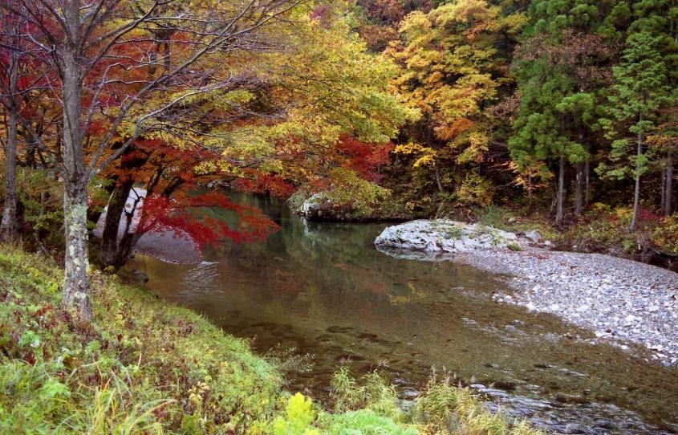
Watersheds are an important part of our ecosystem! Are we mindful of them?!

Description
Through this case study, you will explore how developments and anthropogenic factors can affect the quality of water in Ontario. We will take a close look at the impact of Enbridge’s line 5 on the environment, on Lake Ontario, Lake Erie, and Lake Superior, and how it has and continues to have, detrimental effects on all that rely on that fresh source of water. You will then use the provided maps and your findings to build a model of the affected watershed and of the pipeline.

Understanding the issue: READING TIME!
You will take a few moments to read, individually, or in dyads, the following two articles. Take the time to write down the important points here.
Article 1⁽¹⁾: Busting Enbridge’s Line 5 Myths – Part 1: What Are the True Environmental Impacts and Risks?

Article 2⁽²⁾: Busting Enbridge’s Line 5 Myths – Part 2: Enbridge’s Proposed “Solutions”

Notes and doodles from my readings:

Group activity – diving in:

- In your groups, you will now choose (or will be assigned) one of 5 main issues with Line 5.
- You may consult this brochure (Enbridge Line 5 Issues Within the Bad River Reservation; A Brief Overview Provided by Mashkiiziibii Natural Resources Department ⁽³⁾ ) made available by the environmental defence and you may also conduct your own research to understand the severity of each concern.
- Write down the important points below since you will use them to present your finding using an infographic (consult the rubric for the success criteria).
- For your infographic, you may choose to use a template from Piktochart ⁽⁴⁾
- Video Tutorials are also available here ⁽⁵⁾

My teammates
Our chosen/assigned issue with Line 5
Summary of the main concerns
(What is the issue/problem?
Who does it affect?
What can be done to salvage the situation?

What information should figure on the infographic?
Other important details
So what’s the debate?
As a class, the student will read this Global news article⁽⁶⁾ entitled: “Enbridge Line 5: Canada invokes 1977 treaty again over dispute” and watch the accompanying video:

Also, take a look at Enbridge’s Point of View: Line 5 fact sheets and brochures

Particularily and their summary of the impact of Line 5 Shutdown.

Answer this one question:

There is a different point of view that is being presented.
What is it and what is your opinion on it?

Putting it all together:

Now that you understand the issues and the debate around Line 5, it’s time to use all the information presented to analyze the situation and answer important questions summing it all up.

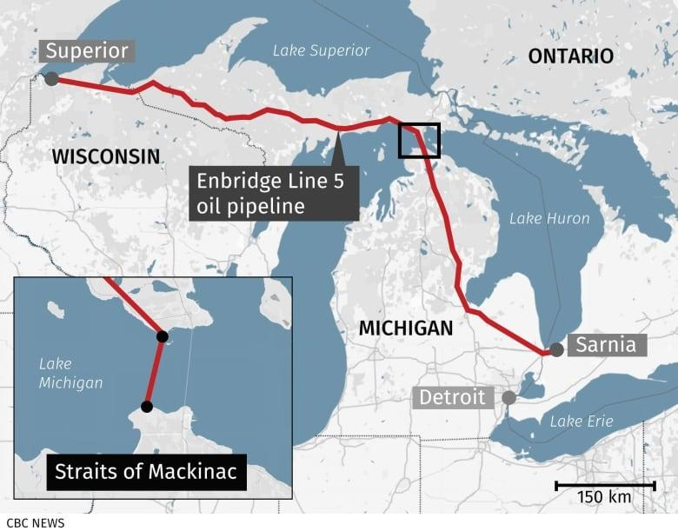
Image from article⁽⁷⁾: Barker, J. (2021, May 10) Canadians Who Rely On Line 5 On Edge As Michigan's Deadline Looms To Shut Enbridge Pipeline | CBC News, from
- Define the following terms:
  - Watershed
  - Development

- What are some current developments occurring locally? How does Line 5 fit with those?

- Which watershed is Line 5 impacting? How?

- Who benefits from this development (Line 5)?

- How does this pipeline impact farmers, local reserves, businesses, homes, etc.?

- What are the opinions on this development from local community members?

- How does this case study highlight the collaboration between neighbouring countries about common resources? In other words, how are Canada and the United States collaborating to find a solution?

- How does this relate to the sustainable development goals defined by the UN?

- Were local Indigenous communities consulted on the development process? Were The United Declaration of the Rights of Indigenous people Article 23, Article 26, Article 29, Article 32, Article 37upheld?

Building a model watershed

- In this part of the activity, you will come together as a class and use the engineering design process to build a model of Enbridge’s Line 5 Pipeline passing through the main parts of your chosen watershed.
- You will show on the map the suggested alternative route.
- You will also model an alternative solution to satisfy all (or most) of the affected parties.
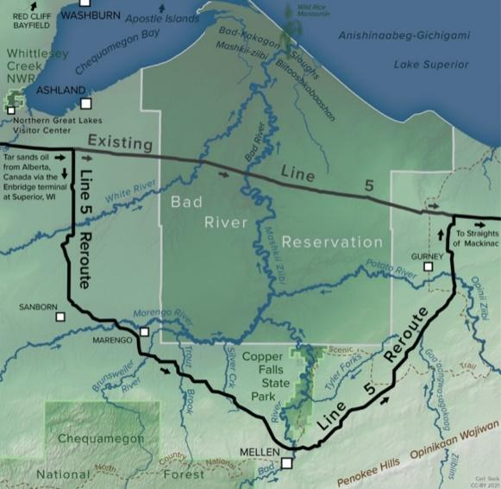

Let’s take a look together at the design process PPT and take it from there!

Image Source : https://indiancountrytoday.com/news/enbridge-takes-the-gloves-off-in-line-5-battle
Student Handout - Bibliography:
- Woodhouse, M. (2022, August 9). Busting Enbridge’s Line 5 Myths – Part 1: What Are the True Environmental Impacts and Risks? Environmental Defence. Retrieved September 10, 2022, from https://environmentaldefence.ca/2022/08/09/busting-line-5-myths-part-1/

- Woodhouse, M. (2022b, September 2). Busting Enbridge’s Line 5 Myths – Part 2: Enbridge’s Proposed “Solutions.” Environmental Defence. Retrieved September 10, 2022, from https://environmentaldefence.ca/2022/09/02/busting-line-5-myths-part-2/

- Enbridge Line 5 Issues within the Bad River Reservation ~a Brief Overview Provided by Mashkiiziibii Natural Resources Department~. 2020.
URL : http://www.badriver-nsn.gov/wp-content/uploads/2020/02/202002_NRD_EnbridgeLine5_Brochure.pdf

- Piktochart. “Piktochart Infographics.” Piktochart Infographics, 8 Aug. 2018
‌URL : https://piktochart.com/

- “Video Tutorials.” Piktochart, piktochart.com/piktochart-tutorials/. Accessed 8 Sept. 2022.
‌URL : https://piktochart.com/piktochart-tutorials/
- Connolly, A. (2022, August 30). Enbridge Line 5: Canada invokes 1977 treaty again over dispute. Global News. Retrieved September 10, 2022, from https://globalnews.ca/news/9092751/canada-line-5-treaty-invoked/
- Barker, J. (2021, May 10) Canadians Who Rely On Line 5 On Edge As Michigan's Deadline Looms To Shut Enbridge Pipeline | CBC News, from https://www.cbc.ca/news/canada/windsor/line-5-pipeline-deadline-1.6020665.

Appendix B: Student Activity Guide - Case Study 3B Highway 413

Case study
Our way or the highway!
Name: Date:
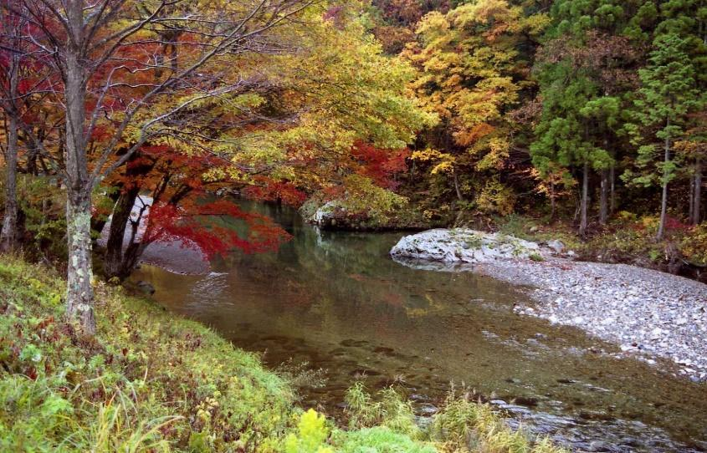
Watersheds are an important part of our ecosystem! Are we mindful of them?!

Description
Through this case study, you will explore how developments and anthropogenic factors can affect the quality of water in Ontario. We will take a close look at the impact of the construction of highway 413 on the neighbouring watershed and how it has, and continues to have, detrimental effects on all that rely on that fresh source of water. You will then use the provided maps and your findings to build a model of the affected watershed and of the highway in order to find an alternative solution.

Understanding the issue: READING TIME!
Start by following this link to explore the plan and vision put together by the Ontario Ministry of Transportation.

You will take a few moments to read, individually, or in dyads, the following two articles. Take the time to write down the important points here.
Article 1⁽¹⁾: Hanrahan, L. (2021, November 24). Everything you need to know about Ontario's controversial Highway 413.

Article 2⁽²⁾: Sarkaria, P. (2022, April 25). Opinion | There should be nothing controversial about building Highway 413. thestar.com.

Notes and doodles from my readings:

Group activity – diving in:

- In your groups, consult the environmental defence organisation website here
- Consult articles and reports of your choosing made available by environmental defence and you may also conduct your own research to understand the severity of the main concerns related to the construction of Highway 413.
- As a class, make a list on the board of at least 13 of those concerns/issues.
- You will then be assigned, as a class ONE of the main concerns/issues discussed to present the important information related to it in the form of an Infographic!
- Write down the important points below since you will use them to present your finding using an infographic (consult the rubric for the success criteria).
- For your infographic, you may chose to use a template from Piktochart ⁽⁴⁾
- Video Tutorials are also available here ⁽⁵⁾

My teammates
Our chosen/assigned issue with Highway
Summary of the main concern assigned to your group.
(What is the issue/problem?
Who does it affect?
What can be done to salvage the situation?

What information should figure on the infographic?
Other important details

Putting it all together:

Now that you understand the issues and the debate around highway 413, it’s time to use all the information presented to analyze the situation and answer important questions summing it all up.
- Define the following terms:
  - Watershed
  - Development

- What are some current developments occurring locally? How does highway 413 fit with those?

- Which watersheds are affected by the construction of highway 413 and how?

- Who benefits from this highway? Why did Ontario initiate the construction of highway 413 in the first place? (Think about its advantages)

- How does this highway impact farmers, local reserves, businesses, homes, etc.?

- What are the opinions on this development from local community members?

- How does this relate to the sustainable development goals defined by the UN? (Does it support any? Does it go against any?)

- What are treaties? How do they come into effect in situations such as this one?

- Were local Indigenous communities consulted on the development process? Were The United Declaration of the Rights of Indigenous people Article 23, Article 26, Article 29, Article 32, Article 37 upheld?

Building a model of the highway!!

- In this part of the activity, you will come together as a class and use the engineering design process to build a model of the proposed highway passing through the main parts of a watershed of your choice.
- You will show on the map the suggested alternative route.
- You will also model an alternative solution to satisfy all (or most) of the affected parties.
Scan this barcode for a map of the highway.
Let’s take a look together at the design process PPT and take it from there!

Appendix C: Article - Everything you need to know about Ontario's controversial Highway 413

Everything you need to know about Ontario's controversial Highway 413
dailyhive.com/toronto/ontario-highway-413-everything-to-know
Laura Hanrahan
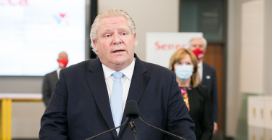Premier Doug Ford (Premier of Ontario Photography/Flickr)
The Government of Ontario is moving full steam ahead with its plans for Highway 413, despite a very mixed reception.
The highway has been in the works for many years but appears to finally be coming to fruition. Here’s everything you need to know about the project.
What is Highway 413?
It’s a proposed four to six-lane highway backed by the Ford government that would provide a new 59-kilometre-long transit corridor from Highway 400 in Vaughan to the intersection of the 407 and the 401 at the Mississauga/Brampton border.
Also known as the GTA West Corridor, the highway was first considered in 2005, but the idea was eventually killed by former Premier Kathleen Wynne’s government before being revived by the Ford government in 2018.

No schedule for construction or completion has been released, but the government did confirm that the highway would not be tolled.
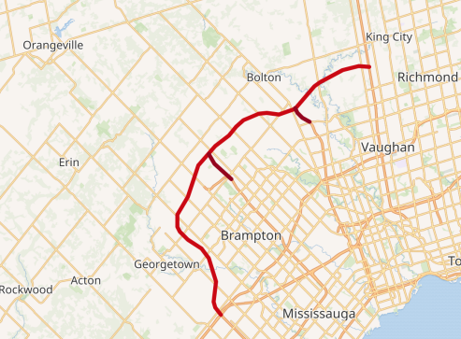Wikimedia
How much will it cost to build?
In its fall economic statement, the Ford government committed to funding the new highway but did not provide a breakdown on how much of the budget the highway accounts for.
The most recent estimates from the previous Liberal government pegged the cost of the project around $6 billion. The current government did reveal, however, that it will spend $1.6 billion over the next six years for bridge rehabilitation ahead of both the Highway 413 project and the proposed Bradford Bypass.
Will Highway 413 cut down driving time?
According to the provincial government, the new highway will save 30 minutes for drivers travelling the entire length of the route compared to taking Highway 401 and Highway 400. This number, however, has been questioned by some experts who say that as the number of cars continues to grow, speeds on the new highway during peak travel times will drop.

What has the response been?
The proposed highway has received a very mixed response, with many prominent figures, and even cities themselves, condemning the project. Mississauga, Halton Hills, Orangeville, and Brampton City Councils voted to formally oppose the province’s plan. They cited negative environmental impacts, increased dependence on cars, and encouraged residential sprawl as negatives of the 400-series highway.
Ontario Liberal leader Stephen Del Duca has been a vocal opponent of the highway, tweeting earlier this month, “Highway 413 is a mirage. It does not represent progress, and it does not represent relief. This highway would only deliver more benefits for Doug Ford’s well-connected friends. Ontarians deserved better from today’s Fall Economic Statement.”
Numerous petitions and campaigns have also popped up calling for the end of the highway plans and, alternatively, an investment in public transit.
Supporters of the highway have lauded the Ford government for the investment in driving conditions and expressed excitement at the possibility of a shorter commute.

Appendix D: There should be nothing controversial about building Highway 413

There should be nothing controversial about building Highway 413
thestar.com/opinion/contributors/2022/04/25/there-should-be-nothing-controversial-about-building-highway-413.html April 25, 2022
I hear it from Brampton families all the time: they’re tired of sitting in bumper-to-bumper traffic when all they want is to get home or to work faster.
Unfortunately, the families I’m speaking to aren’t alone. Highway congestion is a problem facing too many communities in Ontario. That’s because previous governments found every excuse to say “no.” They kicked decisions down the road, formed committee after committee and asked for endless studies. The result was decades of delay as traffic and congestion only got worse.
Ministry of Transportation modelling shows that by 2051, travel times on the main stretch of Highway 401 will double. Yet, there are still some, including individuals quoted in recent Toronto Star articles and an editorial in the same paper, that say building highways is controversial.
There is nothing controversial about building the roads, highways and transit required to meet the needs of a growing province. In fact, it’s common sense.
I represent one of the fastest growing regions in Canada and whether it’s schools, hospitals, transit or roads, new infrastructure has not kept pace with our population. In the coming decades, the GTA is expected to increase by millions more people. While that’s welcome news as we attract more skilled workers to build the future of our province, within the next decade all major highways in the region, including Highway 407, are expected to be at or exceed capacity during rush hour.
We need to build the infrastructure that will support this growth and we need to build it now. That’s why our government is saying “yes” to building Highway 413, a new 400-series highway across Halton, Peel and York regions.
Highway 413 will cut commute times for GTA drivers by 30 minutes each way, adding one extra hour to their day and five hours to their week. It will get goods to market faster, helping to move our economy and workers forward.
The route for Highway 413 was chosen after extensive consultation with stakeholders and based on expert recommendations. As is the case with every major infrastructure project, there is no option that will make every person happy. Each route will have its own pros and cons that need to be weighed carefully.
1/3
At the same time, these decisions should seek to minimize disruption as much as possible. That’s why Ontario has a process in place to evaluate and reduce the impact of any major infrastructure project on local communities. In fact, that process for Highway 413 is currently underway, including continued engagement with the people living around the project.
These processes, while important, should never give licence to opponents of major infrastructure projects like Highway 413 to engage in endless debate and delay. At some point, we need to make decisions in the best interest of our province and the people who live here.
It’s also unrealistic that the growth we’ll experience over the coming years can be addressed by expanding public transit alone. The Liberals and NDP will try to tell you there’s a false choice between building highways and transit. That’s not true. Our government is saying “yes” to both.
We’re building the largest transit expansion in the province’s history, we’re expanding GO rail service, and we’re building the roads, bridges and highways that will help commuters get to where they need to go faster.
Rather than build this highway, Liberal leader Steven Del Duca and NDP leader Andrea Horwath will debate the project endlessly.
GTA drivers can’t afford more delays. There’s nothing controversial about building Highway 413.

Appendix E: Infographic Rubric

Student Evaluation: Infographics
 | Level 1 | Level 2 | Level 3 | Level 4
Knowledge and understanding
Understanding of the elements under study  •Concepts | The student demonstrates a limited understanding of the concepts under study. | The student demonstrates  a partial understanding of the concepts under study. | The student demonstrates a good understanding of the concepts under study. | The student demonstrates  a thorough understanding of the concepts under study.
Thinking skills
Use of critical thinking and creative thinking processes  •Organization of public information according to the targeted audience | The student uses the processes of critical thinking and creative thinking with limited effectiveness. | The student uses the processes of critical thinking and creative thinking with some efficiency. | The student uses the processes of critical thinking and creative thinking effectively. | The student uses the processes of critical thinking and creative thinking with great efficiency.
Communication
Expression and organization of ideas and information  •Organization and presentation  •Clarity (limiting to 3-4 colour pallet)  •Consistency (limited type of typography) | The student expresses and organizes ideas and information  with limited efficiency. | The student expresses and organizes ideas and information  with some efficiency. | The student expresses and organizes ideas and information  effectively. | The student expresses and organizes ideas and information  very effectively.
Use of conventions and terminology under consideration  •Appropriate vocabulary used correctly  •Appropriate representation of the data (like including units) | The student uses the conventions and terminology under study  with limited effectiveness. | The student uses the conventions and terminology under study  with some efficiency. | The student uses the conventions and terminology under study  effectively. | The student uses the conventions and terminology under study  with great efficiency.
Implementation
Transfer of knowledge and skills to new contexts  •Link to familiar concepts and skills  •Link to new concepts and skills | The student transfers knowledge and skills to new contexts  with limited effectiveness. | The student transfers knowledge and skills to new contexts  with some efficiency. | The student transfers knowledge and skills to new contexts  effectively. | The student transfers knowledge and skills to new contexts  with great efficiency.

